**Task # 1:** Take any integer as input, if the number is greater than 5 print it

If a >5, print a

Else if a = 0, then Halt

Else if a < 5, then halt

**Code:**

IN

STO 97 //a

LDA 98

SUB 98

BRP 06

BR 08

LDA 97

OUT

HLT

*98

DAT 005

**Output:**

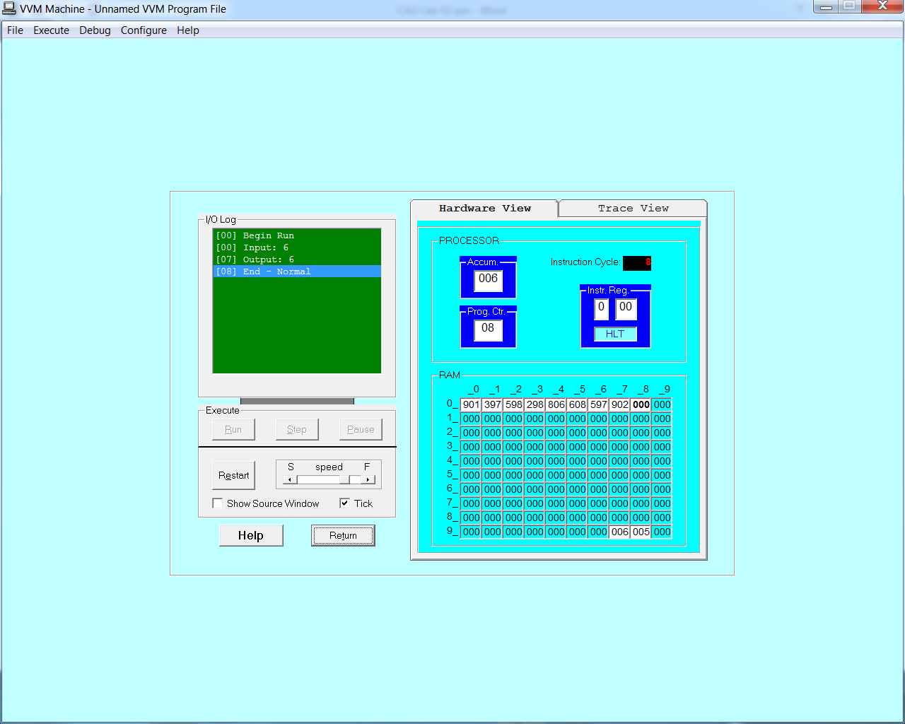

**Task # 2:** Take two numbers as input and print the larger number.

**Code:**

IN

STO 97 //a

IN

STO 98 //b

LDA 97

SUB 98

BRP 10

LDA 98

OUT

BR 12

LDA 97

OUT

HLT

**Output:**

